Results of
Seismic Piezocone Penetration Tests
Performed in Memphis, Tennessee

GTRC Project Nos. E-20-F47/F34

submitted to

USGS/MAE
Hazard Mapping Program
Central Region

by

Georgia Tech Research Corporation
Geosystems Engineering Division
Civil & Environmental Engineering
Atlanta, GA 30332-0355

May 12, 2000

Date: May 12, 2000

To: Dr. Buddy Schweig
Central U.S. Coordinator
Earthquake Hazards Program
USGS/MAE
Campus Box 526590
The University of Memphis

Memphis, TN 38152-6590

Re: Results from Seismic Piezocone Penetration Tests
Five Sites at Mud Island, Memphis, TN
GTRC Project Nos. E-20-F47/F34

Dear Dr. Schweig,

We have prepared this document of recent field testing in the Memphis area in association with USGS award no. 00HQGR0025 and MAE project GT-12.

- Introduction:

This report documents the results of six seismic piezocone penetration tests (SCPTu) conducted for the purpose of site characterization and shear wave velocity measurements at Mud Island in March of 2000. The collected data have also been used to perform a standard liquefaction evaluation of the subsurface materials. A brief overview of the cone penetration test (CPT) equipment and procedures used for this study will be discussed, followed by descriptions of the sites, presentation of the CPT data, and synopsis of the results of the liquefaction evaluation.

- Seismic Piezocone Tests:

2.1 Equipment

The cone penetrometers are manufactured by Hogentogler & Company and consist of 36-mm (10-tonne) and 44-mm (15-tonne) units (Figure 1) with the force reflecting the rating of the point tip capacity. The 36-mm diameter cone has a 60º apex at the tip, 150-cm² sleeve surface area, and a shoulder position (u₂) porewater pressure element. A velocity geophone and an inclinometer are located approximately 18-cm behind the tip. The 44-mm diameter cone has a 60º apex at the tip, 225-cm² sleeve surface area, and a u₂ porewater pressure element. A velocity geophone and an inclinometer are located approximately 23-cm behind the tip. The cones were vertically advanced at the standard rate of 2 cm/sec (Lunne et al., 1997) while readings of tip resistance (q_{c}), sleeve friction (f_{s}), inclination (i), and pore pressure (u₂) were taken every 5-cm.
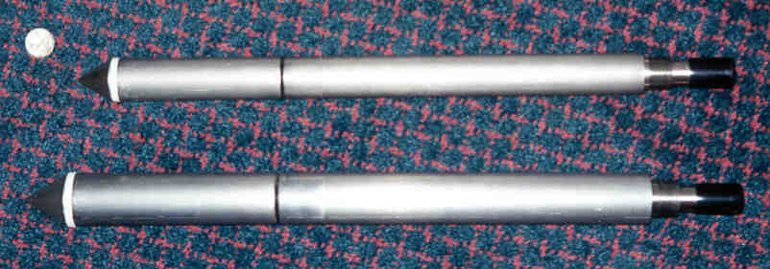

Figure 1. 36-mm (top) and 44-mm Diameter Penetrometers

The rig is a GT GeoStar cone truck manufactured by Hogentogler and is based on a Ford F350 Super Duty truck chassis with a hydraulic pushing system. The truck utilizes twin screw earth anchors for increased reaction against lifting during CPT soundings. The data acquisition system is a Hogentoler IBM compatible field computer that interfaces between the truck and cone.

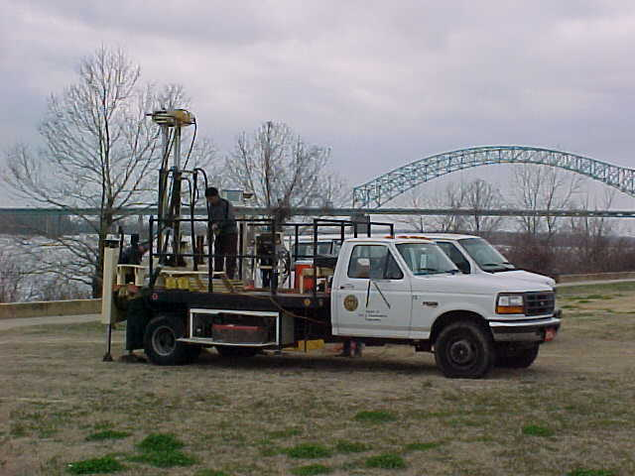

Figure 2. GT GeoStar Cone Truck at Mud Island

2.2 Testing Procedures

Cone penetration tests (CPT) were performed in general accordance with ASTM D-5778 using an electronic cone penetrometer and computer data acquisition system. Readings of resistance (q_{c}), sleeve friction (f_{s}), inclination (i), and pore pressure (u₂) were taken every 2.5 seconds. The tip resistance (q_{c}) is measured as the maximum force over the projected area of the cone tip. It is a point stress related to the bearing capacity of the soil. The measured q_{c} must be corrected for porewater pressure effects on unequal areas (Lunne, et al., 1997), especially in clays and silts where porewater pressures typically vary greatly from hydrostatic. This corrected value is known as q_{t}, which is reported in Appendix C. The u₂ position element is required for the measurement of penetration porewater pressures and the correction of tip resistance. The sleeve friction (f_{s}) is used as a measure of soil type and can be expressed by friction ratio: FR = f_{s}/q_{t}.

Seismic tests were performed at roughly 1-meter (3.3-foot) increments. The shear waves were generated by striking a horizontal steel plank that was coupled to the ground under the weight of a truck outrigger. The plank was positioned approximately 1.5 m away (horizontally) from the axis of the sounding location. The geophone is oriented to detect vertically-propagating, horizontally-polarized shear waves emanating from the ground-surface. At least one wave train was measured at each depth. A pseudo-interval shear wave velocity (V_{s}) analysis was then performed. The pseudo-interval shear wave velocity is simply the difference in travel distance between any two successive events divided by the difference in travel times (Campanella, et al, 1986). The travel times were determined in two ways: (1) by visually inspecting the recorded wave traces and subjectively identifying the first arrival, and (2) by a rigorous post-processing technique known as cross-correlation to determine the time shift between the entire wave trains from successive paired records (Campanella & Stewart, 1992).

3. Test Sites

Mud Island was originally formed by dredge spoil taken from the Mississippi river. The area currently forms a peninsula located on the northwestern edge of downtown Memphis, Tennessee. The approximate locations of the five test sites are shown in Figure 3. Appendix A shows the individual plan layouts of the sites with reference to pertinent landmarks.

Six soundings were performed at Mud Island, including two for site A and one at each of the remaining sites (B, C, D, and E). For the first sounding at site A (designated A1), shear wave measurements were terminated at a depth of 18.6 meters due to technical difficulties but the CPT sounding continued to a depth of 32.8 meters. Due to the premature termination of the seismic measurements, a second sounding was performed at site A. For the second sounding at site A and for all of the other soundings as well, shear wave measurements were made over the entire depth of the sounding.

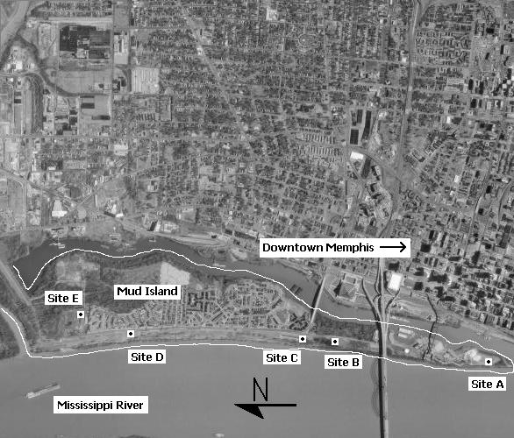

Figure 3. Overview of the Test Site Locations at Mud Island, Memphis, TN

- Data Summary

Table 1 lists pertinent information about each sounding including the coordinate locations obtained by GPS and maximum penetration depth. Plots of the four independent readings from each of the seismic piezocone soundings are given in Appendix B and include the corrected cone tip resistance (q_{t}), sleeve friction (f_{s}), penetration pore water pressure (u₂), and shear wave velocity (V_{s}). In addition, Appendix B provides the derived profiles of the small-strain shear modulus (G₀ = ρV_{s}²), mass density (ρ), shear strain (γ_{s}= ů/V_{s}), and soil behavioral classification (interpreted using the empircal 1986 Robertson-Campanella charts). For the shear strain calculation, the peak particle velocity (ů) is taken as the maximum amplitude of the shear wave signal at a given depth since the geophone output voltage is proportional to its velocity.

Table 1. List of Soundings Performed at Mud Island, Memphis, TN

Sounding  Location | Maximum  Depth (m) | Coordinates by GPS
Site A1 | 32.8 | N-35o08.681’ W-90o03.559’
Site A2 | 30.6 | N-35o08.681’ W-90o03.559’
Site B | 30.5 | N-35o09.388’ W-90o03.413’
Site C | 38.2 | N-35o09.583’ W-90o03.385’
Site D | 28.3 | N-35o10.541’ W-90o03.323’
Site E | 24.0 | N-35o10.668’ W-90o03.191’

A complete digital output of the penetration records for each SCPTu soundings is given in Appendix C. These results are included only in selected printed copies of the report for documentation. In addition, CD versions of the report are available for processing of data in future studies.

Appendix D provides a digital summary of the downhole shear wave results and shows the paste-ups for the shear waves obtained at different depths. A low-pass filter is applied to the shear waves in order to eliminate the high frequency noise present in the signal. To do this, each record in the time domain is passed to the frequency domain. Frequencies over 500 Hz are removed and then the signal is returned to the time domain. The amplitude of the shear waves is then normalized for plotting the graph. Cross-correlation is done between consecutive waves in order to obtain the time shift between records. The shear wave velocity (V_{s}) is calculated by dividing the distance between two consecutive measurements with the time shift.

- Liquefaction Evaluation

The liquefaction potential of the five sites was evaluated using two procedures, one based on normalized tip stress (Robertson & Wride, 1997) and one based on normalized shear wave velocity (Andrus & Stokoe, 1997). For the normalized tip stress-based method, the cone tip resistance is normalized by the effective stress (actual normalization criteria depends upon the CPT soil classification) and then corrected for the apparent fines content, which is empirically calculated from the CPT data as well. Ultimately, a normalized and corrected tip resistance is obtained that is used to establish the cyclic resistance ratio. With the shear wave velocity procedure, the shear wave velocity is normalized by the effective stress and the fines content is accounted for through the selection of one of three cyclic resistance ratio equations. Both methods also include corrections for earthquake magnitude and the effective overburden stress.

For both liquefaction evaluation methods, the seismic “demand” must be known or assumed. In liquefaction analyses, the seismic loading is typically expressed in terms of the cyclic stress ratio. Furthermore, for the common simplified procedures, the cyclic stress ratio is most often expressed as (Seed & Idriss, 1971):

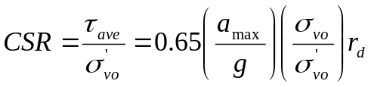

where a_{max} is the peak ground acceleration generated by the earthquake of interest, g is the acceleration of gravity, σ_{vo} and σ’_{vo} are the total and effective vertical stresses, respectively, and r_{d} is a stress reduction coefficient that accounts for the flexibility of the model soil column. Various r_{d} coefficients have been proposed by many different researchers. However, for this work, the r_{d} recommendations of the NCEER Workshop on Evaluation of Liquefaction Resistance of Soils (1997) were followed, which are actually a compilation of the coefficients proposed by several researchers. Ordinarily, a_{max} is taken from the appropriate design events for a given project (i.e., the 2%, 5%, or 10% probability earthquake; the maximum credible event for a known fault located x km from the site; a code based response spectrum, etc.). However, since Mud Island is not associated with any particular known earthquake event, the relevant value for a_{max} is not known. This has been a fairly common problem faced by researchers in the seismic Mid-America region and as a result, simulated ground motions have been generated for several Mid-America cities, including Memphis (Wen & Wu, 1999).
The simulated ground motions are intended to provide a common reference point for seismic analyses performed in the region by the various Mid-America researchers. It should be noted that the simulated ground motions are not intended for engineering design, nor as replacements to the various building codes that may be in effect. Since this cursory liquefaction analysis is not intended to be used for the design or evaluation of any actual projects, the simulated ground motions provide a rational means of selecting a_{max} for these research-related liquefaction analyses.
Based on the Wen & Wu simulated ground motions for the “Representative Soil Profile for Memphis” and an event having a 2% probability of exceedance in 50 years, a value of 0.38 was selected for a_{max} (see Wen & Wu figure 19, 1999). This event has an estimated magnitude of 8.0.
The results of the liquefaction analyses are summarized on plots in Appendix B. The CPT based procedure is presented as the critical value of tip resistance that would yield a factor of safety against liquefaction of 1.0. This critical q_{t}, which changes with depth, is shown in the same graph as the measured q_{t}. Liquefaction is likely wherever the measured tip resistance is less than the critical tip resistance. The gaps in the critical tip resistance data represent soil layers that are not susceptible to liquefaction due to their classification (i.e., clayey soils for which liquefaction analyses are not relevant).

For the shear wave velocity procedure, the results are summarized in the form of factor of safety plots vs depth. The factor of safety is defined as the cyclic resistance ratio divided by the cyclic stress ratio. Soil type cannot be determined from shear wave velocity and the reported factor of safety does not consider soil classification. Consequently, in the attached plots, factors of safety of less than 1 may be computed for clayey strata that are actually not liquefiable. Gaps in the factor of safety plots represent zones that had very large factors of safety against liquefaction.

- Closure

We appreciate the opportunity to work with you on this joint USGS-MAE project.

Sincerely,

Tianfei Liao Guillermo Zavala
Research Assistant Research Assistant
Phone: 404-385-0057 Phone: 404-385-0058
E-mail:gte611q@prism.gatech.edu E-mail: gte577q@prism.gatech.edu

Billy Camp Alec McGillivray
Research Assistant Research Assistant
Phone: 404-385-0057 Phone: 404-385-0066
E-mail:gte032s@prism.gatech.edu E-mail: gtd442a@prism.gatech.edu

Paul W. Mayne, PhD, P.E.
Professor
Phone: 404-894-6226
E-mail: pmayne@ce.gatech.edu
References:

- Andrus, R.D. and Stokoe, K.H. (1997), “Liquefaction Resistance Based on Shear Wave Velocity”, Proceedings of the NCEER Workshop on Evaluation of Liquefaction Resistance of Soils, Technical Report NCEER-97-0022, National Center for Earthquake Engineering Research, Buffalo, New York, p. 89-128.
- ASTM D 5778-95 (1997), Standard Test Method for Performing Electronic Friction Cone and Piezocone Penetration Testing of Soils, ASTM Section 4, Vol. 4.09 Soil and Rock (II): D 4943 - latest; Geosynthetics.
- Campanella, R.G. and Robertson, P.K. (1988), “Current status of the piezocone test”, Penetration Testing 1988, Vol. 1 (Proc. ISOPT-1, Orlando), Balkema, Rotterdam, 93-116.
- Campanella, R.G., Robertson, P.K., and Gillespie, D. (1986), “Seismic cone penetration tests”, Use of In-Situ Tests in Geotechnical Engineering, (GSP 6), ASCE, Reston, VA, 116-130.
- Campanella, R. G. and Stewart, W.P. (1992), “Seismic cone analysis using digital signal processing for dynamic site characterization”, Canadian Geotechnical Journal, Vol. 29, pg. 477-486.
- Jamiolkowski, M., Ladd, C.C., Germaine, J. and Lancellotta, R. (1985), “New developments in field and lab testing of soils”, Proceedings, 11th Intl. Conference on Soil Mechanics and Foundations Engineering, Vol. 1, San Francisco, 57-154.
- Lunne, T., Eidsmoen, T., Powell, J., and Quarterman, R. (1986), Lab and field evaluations of cone penetrometers. Use of In-Situ Tests in Geotechnical Engineering (GSP 6), ASCE, Reston, VA, 714-729.
- Lunne, T., Robertson, P.K., and Powell, J.J.M. (1997) Cone Penetration Testing in Geotechnical Practice, Blackie Academic and Professional, New York, Currently produced by EF-SPON, New York, 312 pp.
- Robertson, P.K., Campanella, R.G., Gillespie, D. & Grieg, J. (1986), “Use of piezometer cone data”, Use of In-Situ Tests in Geotechnical Engineering (GSP6), ASCE, Reston, VA, 1263-1280.
- Robertson, P.K. and Wride, C.E. (1997), “Cyclic Liquefaction and Its Evaluation Based on the SPT and CPT”, Proceeding of the NCEER Workshop on Evaluation of Liquefaction Resistance of Soils, Technical Report NCEER-97-0022, p. 41-80.
- Robertson, P.K. and Wride, C.E. (1998), “Evaluating cyclic liquefaction potential using the cone penetration test”, Canadian Geotechnical Journal, Vol. 35, pg. 442-459.
- Seed, H.B. and Idriss, I.M., (1971), “Simplified Procedure for Evaluating Soil Liquefaction Potential”, Journal of the Soil Mechanics and Foundations Division, ASCE, Vol 97, No. SM9, p. 1249-1273.
- Wen, Y.K. and Wu, C.L. (1999), “Generation of Ground Motions for Mid-America Cities”, http://mae.ce.gatech.edu/Research.

Appendix A

Layout of the Test Sites
Mud Island, Memphis, TN

GTRC Project Nos. E-20-F47/F34

May 12, 2000

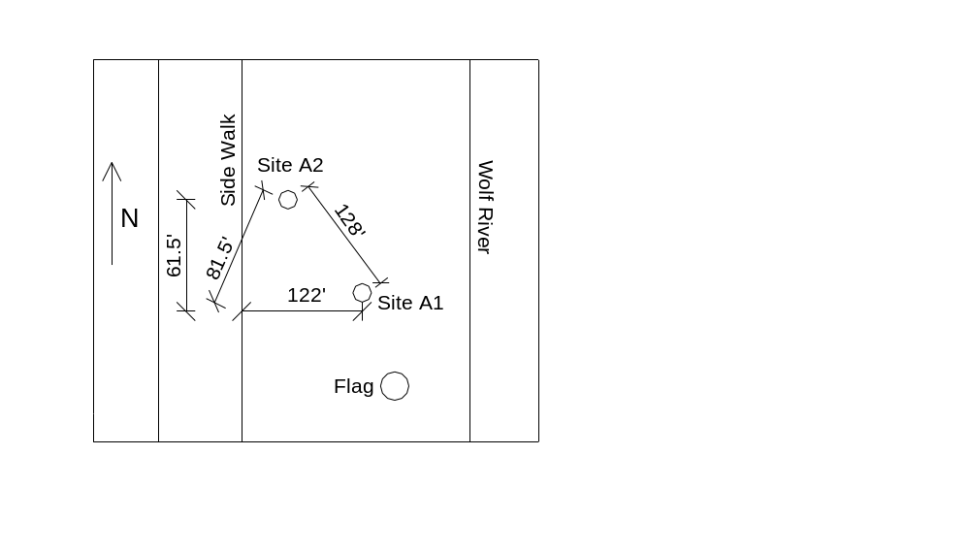

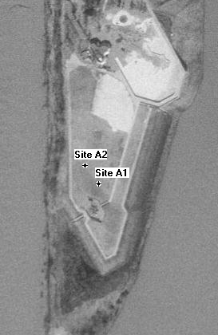

Fig. 1. Layout of Site A, Mud Island, Memphis, TN

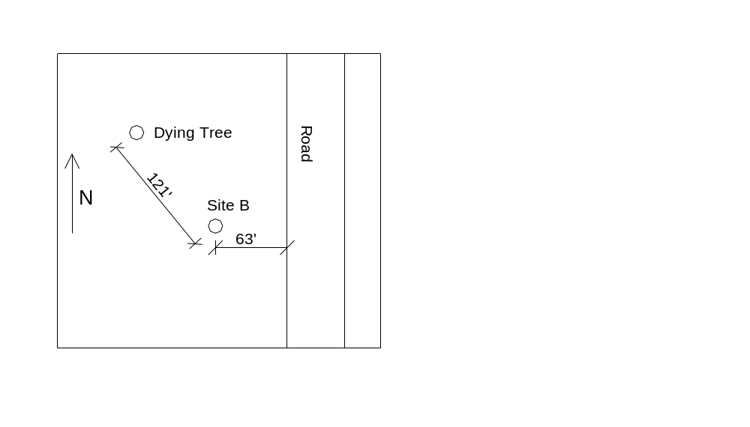

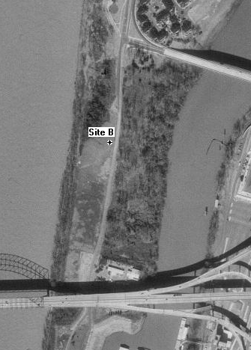

Fig. 2. Layout of Site B, Mud Island, Memphis, TN

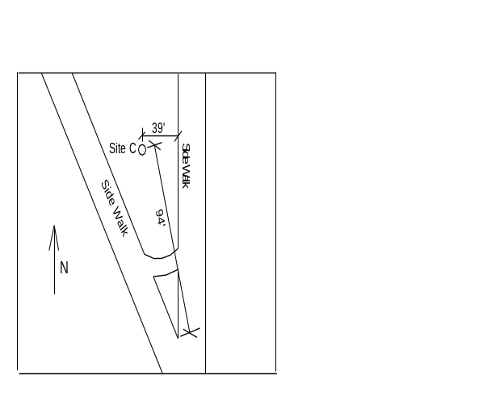

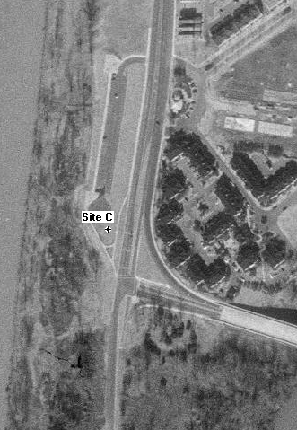

Fig. 3. Layout of Site C, Mud Island, Memphis, TN

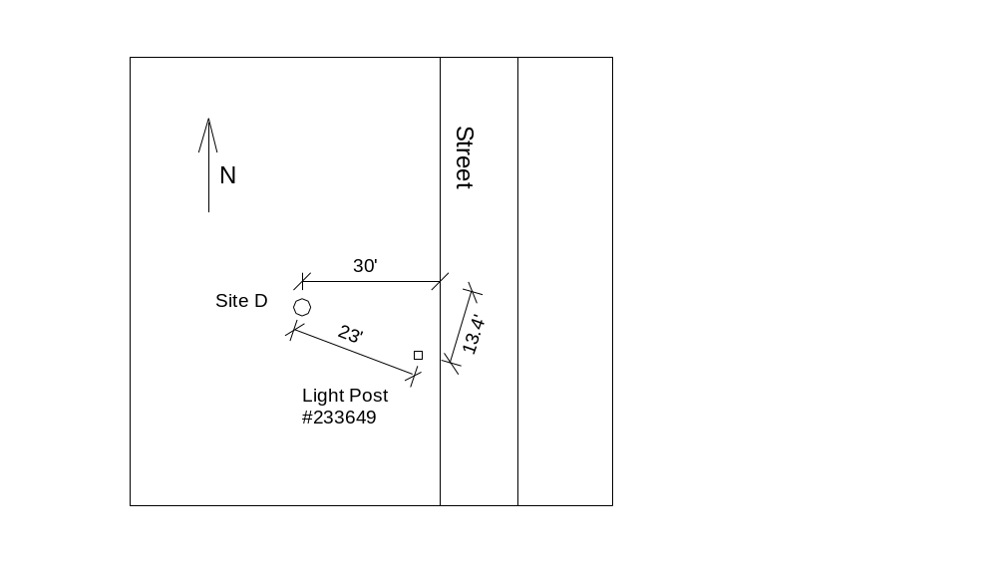

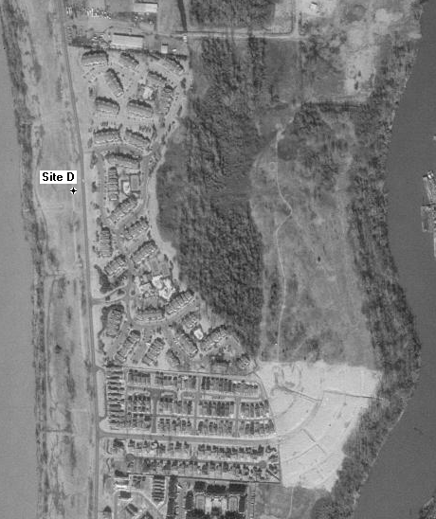

Fig. 4. Layout of Site D, Mud Island, Memphis, TN

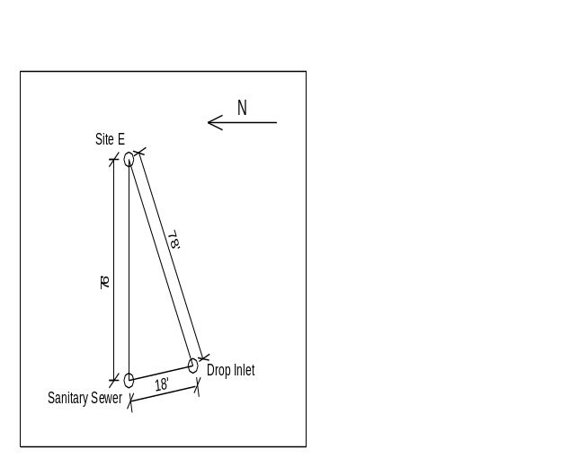

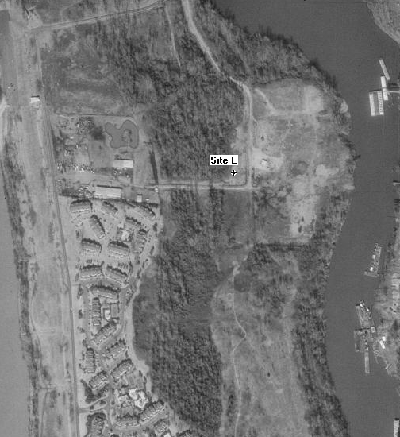

Fig. 5. Layout of Site E, Mud Island, Memphis, TN

Appendix B

Summary Graphs from SCPTu Soundings
Mud Island, Memphis, TN

GTRC Project Nos. E-20-F47/F34

May 12, 2000

Appendix C

Digital Data from SCPTu Soundings
Mud Island, Memphis, TN

GTRC Project Nos. E-20-F47/F34

May 12, 2000

Appendix D

Digital Downhole Shear Wave Data
and
Full Shear Wave Train Profiles
Mud Island, Memphis, TN

GTRC Project Nos. E-20-F47/F34

May 12, 2000

