May 2004

Soil Liquefaction
Undergraduate Research

Developed by: Alisha Kaplan
Under Direction of: Dr. Paul Mayne
Mid-America Earthquake Center and
Georgia Institute of Technology
What is Soil Liquefaction?

During heavy ground shaking by earthquakes, liquefaction occurs when the pressure exerted by the water present in saturated soil becomes so great that the soil particles become ‘suspended’ in the water. A soil deposit that is liquefied behaves like the better known phenomena: quicksand.

A few key terms:
- Saturated soils: soils in which the space (voids) between the soil particles is completely filled with water
- Pore water pressure: pressure exerted on particles of soil by the water in the voids. Most of the time this pressure is relatively low (hydrostatic) and results in an equilibrium condition of effective stress state. However, there are some circumstances in which rapidly increased stresses can cause the pore water pressure to increase.

In more technical terms, liquefaction is imminent when the porewater pressure (u) equals the total overburden stress (σ_{vo}). This creates an effective stress state equal to zero (σ_{vo}' = [σ_{vo} – u] = 0).

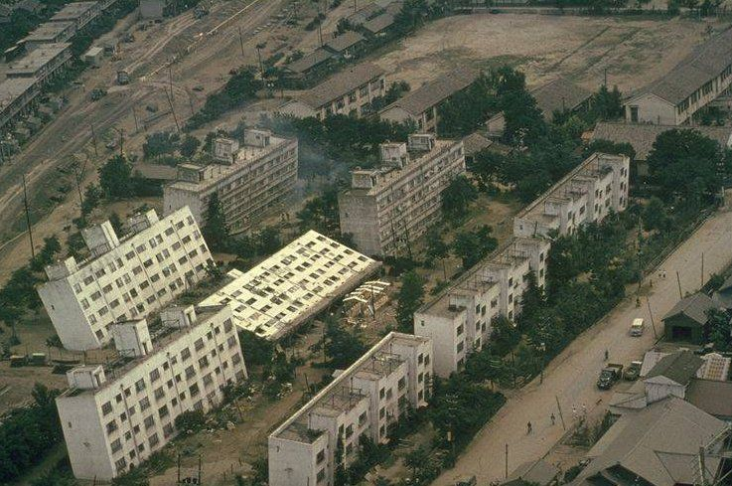
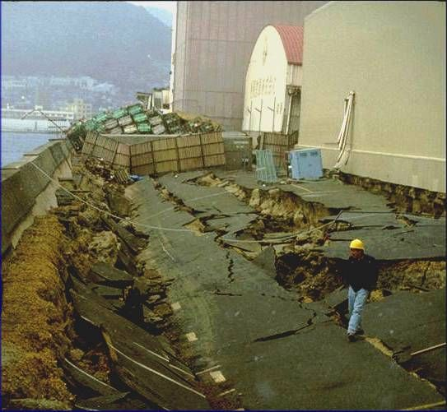
Due to the forces exerted by gravity, soil particles naturally rest upon each other and, depending on the properties of the soil, form sort of grid that is relatively stable (or can be made so by compaction or other construction practices). During liquefaction the water pressures become high enough to counteract the gravitational pull on the soil particles and effectively ‘float’, or suspend, the particles. The soil particles can then move freely with respect to each other. Since the soil is no longer behaving as an inactive grid of particles, the strength and stiffness of a liquefied soil is significantly decreased, often resulting in a variety of structural failures. (The picture at right shows overturned apartment buildings in Niigata, Japan due to liquefaction in 1964. Picture below shows an example of lateral spread failure due an earthquake in Kobe, Japan in 1995.)
Nigata, Japan, 1964

Typically when we discuss liquefaction due to a seismic event, we are addressing “cyclic liquefaction”, which occurs when repeated cycles of shearing generate an accumulation of porewater pressures. However, if the soil is very loose sand, “flow liquefaction” can occur from first time loading during site development. Also, “quasi liquefaction” describes a state of partial liquefaction of a soil deposit that does not propagate fully throughout the site, however the subsurface liquefaction response still negatively affects structures at the surface.
Kobe, Japan, 1995
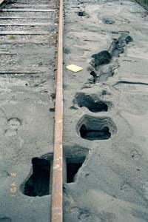
If liquefaction occurs beneath a surface that has hardened as a result of compaction, weathering, or some other process; ‘sand boiling’ can occur. The water pressures build below the surface to the point that the water breaks through the solid surface much like a bubble in boiling water. The pictures at left and below illustrate craters left behind as evidence of sand boiling.

On the US West Coast, these sand boils are normally about one to three feet in diameter (0.3 to 1 meter), see photos at left and below right. In the New Madrid Seismic Zone, the level of sand liquefaction was so extensive that the sand boils in this region are called “sand blows” since they generally are 10 to 100 feet diameter (3 to 30 meters).
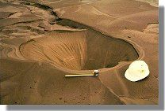
Olympia, Washington, 2001
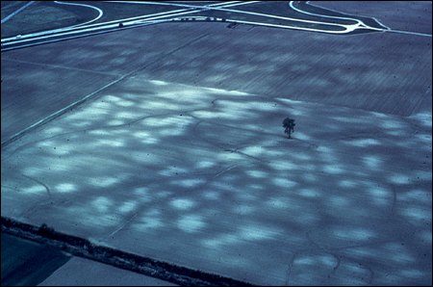
Loma Prieta, 1989
New Madrid Seismic Zone
What is Soil Liquefaction? (cont’d)

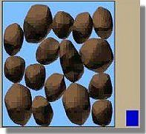
Figure 1

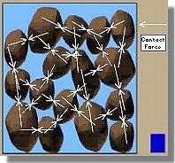
Figure 2

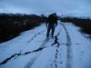
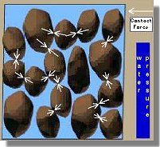
Figure 3

Figures 1 and 2 show a typical view of soil grains in an unexcited, saturated deposit. The blue column on the right indicates the magnitude of porewater pressure present. The arrows in Figure 2 indicate the forces created by the interactions of the soil grains. Figure 3 shows elevated water pressure created by additional loading (as from a seismic event. The increased water pressure acts to ‘float’ the grains and thereby decreases the interaction between grains, thus causing the characteristic properties of liquefaction. [Figures referenced from The Soil Liquefaction web site maintained by the Civil Engineering Department of the University of Washington. See sources for specific information.]

Fielding Lake, Alaska, 2002
What affects whether or not soil liquefaction will occur?
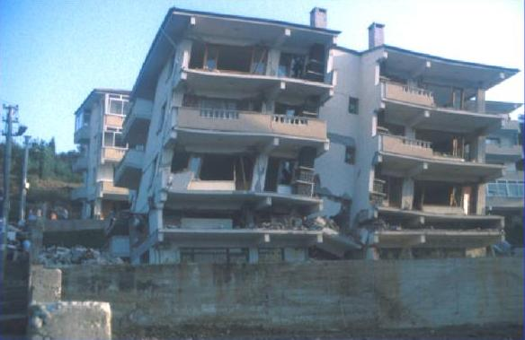
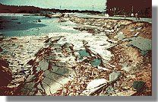
A deposit of soil, by nature, is able to be compacted through the rearrangement of the particles within; but, water is incompressible as a property. As a result, any increase to the stress acting on a saturated soil-provided it occurs rapidly enough and is large enough to completely overcome the resistance presented by the structure of the soil-will cause the water to act alone in resistance and frees the soils to move against each other easily thereby lowered the strength and load-bearing capabilities of the soil (damage to a structure during the 1999 earthquake in Izmit, Turkey is shown above). Thus the phenomena of soil liquefaction is created. Liquefaction is most often known as the result of a major earthquake, but can also be caused by construction practices such as blasting, vibroflotation and dynamic compaction.
Izmit, Turkey, 1999
Lake Merced, California, 1957
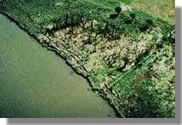
Because soil must be saturated for liquefaction to occur, it is observed most often in areas of low elevation near bodies of water. It should be noted that this can occur easily on river banks as well as near larger bodies of water (pictures at right show sliding in 1957 on the banks of Lake Merced, California, above, and below in 1976 in Guatemala on the Montagua River). Liquefaction can also occur in soil that is completely submerged and commonly causes significant damages to bridge foundations, off-shore oil drilling facilities, and other structures that are supported by submerged soil deposits.
Montagua River, Guatemala, 1976
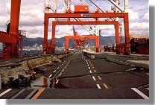
Generally, liquefaction will occur in loose clean to silty sands that are below the groundwater table but still close to the surface of the deposit. Historically, these sands are young Holocene age geomaterials. Below depths of approximately 20m, we generally do not see any evidence of liquefaction. This is due to the fact that deeper soils become compacted by the weight of the soil layer above. In the left image lateral displacement and failure of a quay wall on Port Island, Japan in 1995 can be seen.
Port Island, Kobe, Japan, 1995

Why is liquefaction important?

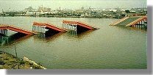
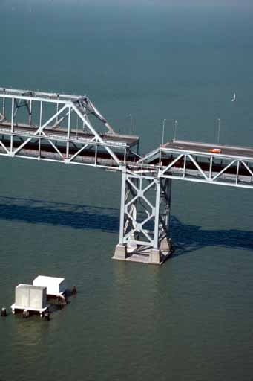
Seismic events, in general, can cause a number of dangerous ground conditions that can lead to structural damage and failure resulting in loss of life. Severe ground shaking, lateral spreading (such as landsliding and deposit movement/shifting), as well as ‘incoherence’. Incoherence is the propagation of a wave in a structure causing foundation or bridge piers to experience movement that is out of sync with the rest of the structure (see bridge failure from 1964 Earthquake in Niigata, Japan, right, and upper deck collapse of Bay Bridge from San Francisco, California 1989, left). Liquefaction may amplify the potential for those conditions and the damage they cause.
Niigata, Japan, 1964

Liquefaction is responsible for extreme property damage and loss of life due to a several variations of failure potential. Liquefied ground is no longer stable to withstand the stresses it is subject to from structural foundations or even its own weight, leading to a variety of potential failures. The witnessed effect on structures with their foundations in a liquefied deposit resembles quicksand with a bearing capacity failure occurring beneath the foundations. The building structures will lean and fall; or at times even split open under the strains (see pictures below of structural damage caused by 1999 earthquake in Izmit Turkey).
Loma Prieta, California, 1989
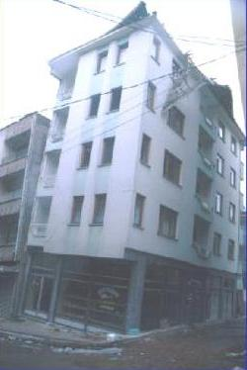
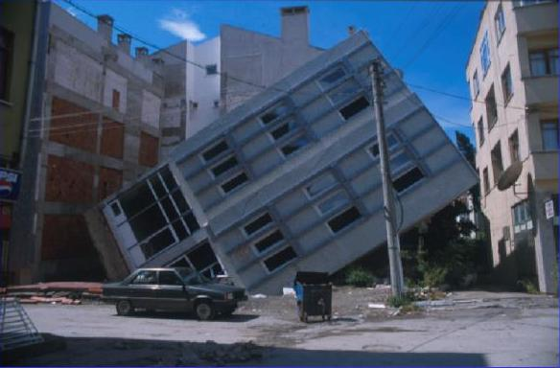
Izmit, Turkey, 1999 (both images)

Also, dams and retaining walls are common boundaries to many major bodies of water and their adjacent shores. Both rely on the strength and stiffness properties of soil for their stability. The failure of the soil around them not only can cause the structure itself to weaken, lean, and possibly even fall; but also can result in ‘subsurface landslides’, during which the supporting soil at the base of the dam or wall loosens and slides out. Dam and retaining wall failure are especially problematic concerns due to the additional potential for flooding.
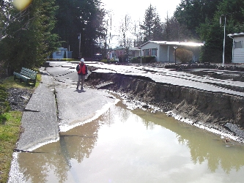
The damaging effects of liquefied soils are not only visible in the structural chaos left behind. The soil itself can be weakened and fail due to its own weight. Often, erosion from rivers and streams cuts into the soil along their banks, leaving behind scoured ground and gullies. The stresses produced during liquefaction can cause tension cracks to form in the soil near the embankment, or it can collapse altogether, commonly known as lateral spreading or landsliding. Soils on or near slopes, hills, or mountains can experience the same effects.
Olympia, Washington, 2001


Lateral spreading during the Kobe earthquake in Japan in 1995 caused the paved surface shown in this picture to fall 1-1.2 meters below original grade. Local flooding occurred as a result.
Kobe, Japan, 1995
How can the risk of damage due to soil liquefaction be reduced?

There are several ways in which risk and severity of damage as a result of soil liquefaction can be reduced. The first and most obvious is, to avoid planning development on liquefaction susceptible soils. Besides in-situ testing, vulnerable sites can also be identified by researching any prior events at the site. Maps showing sites of prior liquefaction can be located from many government and research entities. See links to SIM 2822: Surficial Geologic Map of the Southeast Memphis Quadrangle, Shelby
County, Tennessee and SIM 2823: Surficial Geologic Map of the Southwest Memphis Quadrangle, Shelby County, Tennessee, and Crittenden County, Arkansas, included in the information resources on page 10.

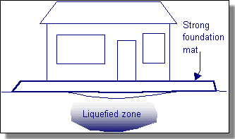
If it necessary to construct on liquefaction susceptible soils, one can modify the design of a structure in several ways to make the structure more resistant damage potential from liquefaction. A structure that incorporates ductility, has supports that are adjustable to accommodate differential settlement, possesses the ability to accommodate large deformations, and has a foundation design that can span ‘soft’ spots, can all decrease the amount of damage incurred in the case of a liquefaction event.
Example of foundation design that spans over a soft spot
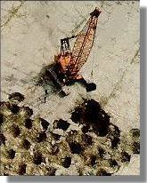
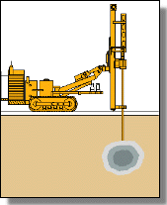
In addition to designing a liquefaction-resistant structure, steps can be taken to improve the soil conditions and lower the potential for liquefaction occurrence. A variety of ground modification techniques are available to change the ground conditions. Methods that increase soil drainage and density can lower liquefaction risk. These include: vibroflotation; vertical wick drains; dynamic compaction; installation of stone columns, compaction piles, and compaction grouting; and use of various drainage improvement techniques are all acceptable options.
Dynamic compaction
Injection & grouting
Where can I find more information?

Liquefaction information can be found in a number of sources: websites, articles in professional journals, and books. Some identified sources are listed below, but to ensure the information is most up-to-date and applicable to your needs, use these resources as a starting point to do some research of your own.

Sources used in this paper

http://www.liquefaction.com/
Site maintained by Dr. Richard Olsen from USAE of waterways experiment station with links to pages on “Evaluation of Earthquake Induced Soil Liquefaction”, “Links and Information for the Geotechnical Cone Penetrometer Test”, “Geotechnical Engineering Information”, and “Geotechnical Web Site Links”

http://neic.usgs.gov/neis/new_madrid/new_madrid.html
Collection of New Madrid Information by USGS

http://mae.ce.uiuc.edu/
Mid-America Earthquake Center

http://www.nees.org/
Network for Earthquake Engineering Simulation

http://www.ce.washington.edu/~liquefaction/html/main.html
Site maintained by the civil engineering department at the University of Washington. “The Soil Liquefaction web site was developed to provide general information for interested lay persons, and more detailed information for engineers. Visitors who are not familiar with soil liquefaction can find answer to typical questions.”

http://www.eeri.org
Homepage for the Earthquake Engineering Research Institute

http://www.ce.gatech.edu/~geosys/Faculty/Mayne/papers/index.html
An index of research papers written by my advisor, Dr. Paul Mayne, in conjunction with the Mid-America Earthquake Center and Georgia Institute of Technology.

http://www.bfrl.nist.gov
National Institute of Standards and Technology – Building and Fire Research Laboratory

http://geoinfo.usc.edu/gees/
Geotech Earthquake Engineering Server

http://earthquake.geoengineer.org
Geotechnical Earthquake Engineering Portal

http://pubs.usgs.gov/sim/2004/2822/
SIM 2822: Surficial Geologic Map of the Southeast Memphis Quadrangle, Shelby
County, Tennessee

http://pubs.usgs.gov/sim/2004/2823/
SIM 2823: Surficial Geologic Map of the Southwest Memphis Quadrangle, Shelby
County, Tennessee, and Crittenden County, Arkansas

Some Seismic Site Analysis Software Available

There are some softwares available that can lend a hand when characterizing a site’s seismic risk. Below is a list of programs found during the course of this research and some basic information about the program itself and its availability. (Note that 1D, 2D, and 3D are modeled with time input as well and thereby can also be called 2D, 3D, and 4D.)

SHAKE2000
Windows compatible 1D analysis of site-specific response and the evaluation of earthquake effects on soil deposits. Integrates former program entities ShakEdit and SHAKE. One-user license costs $250. See www.shake2000.com for more information.

Rockware Visual Seismic (Version 3 – 10/03)
Developed by Rockware Inc. 2D, 3D, and 4D seismic and GPR visualization and interpretation. Demo available, full version available for $1995. http://www.rockware.com for more information or downloadable demos.

SEM2DPACK
2D Spectral Element Method code (in Fortran 95) and utilities for the study of seismic wave propagation in sedimentary basins and earthquake dynamics. Current version is 2.2.1. Available freely for research purposes. http://geoweb.princeton.edu/people/resstaff/Ampuero/software.html

IASPEI Seismological Software Library
The International Association of Seismology and Physics of the Earth's Interior (IASPEI) is a nonprofit professional association dedicated to furthering the knowledge of seismology and solid-earth geophysics. In 1988, IASPEI established a Working Group on Personal Computers to promote the sharing of seismological software. Under the auspices of the Working Group and in collaboration with the Seismological Society of America (SSA), a series of seismological software volumes for IBM-compatible personal computers is being published with W. H. K. Lee as editor, and J. C. Lahr and F. Scherbaum as associate editors. The editorial board is chaired by Hiroo Kanamori and includes R. D. Adams, V. Cerveny, E. R. Engdahl, Y. Fukao, R. B. Herrmann, E. Kausel, V. Keilis-Borok, B. L. N. Kennett, and S. K. Singh. So far, six volumes of the IASPEI Software Library have been published. Each volume includes the executable code and examples on floppy diskettes, and printed documentation (for IBM-compatible PC's only). Volume 1 (first edition 1989; second edition 1994) contains programs for real-time seismic data acquisition, processing, and analysis. It includes a description of the hardware implementation for a PC-based seismic system and programs to perform seismic data acquisition, interactive picking of seismic phases, filtering, spectral and coda Q analysis, and earthquake location. At present, about 150 seismic networks using Volume 1 software are in operation worldwide. The second edition of this volume contains revised software and several new programs, and supports USGS digital telemetry standards and PC-SUDS format. Volume 2 (first edition 1990; second edition 1994) is a companion to the first volume. It contains twelve computer programs for plotting seismic data on the monitor screen and generating a hard copy. It includes a 3-dimensional data-viewing program for rotating, enlarging, or shrinking objects and data points. The second edition of this volume contains several new programs for plotting seismic waveform data in the PC-SUDS format. Volume 3 contains two major programs: (1) SeisGram by Anthony Lomax for interactive analysis of digital seismograms, and (2) SYN4 by Robert McCaffrey, Geoffrey Abers, and Peter Zwick for inversion of teleseismic body waves. This volume (published 1991; updated in 1994 to support the PC-SUDS format) is a toolbox for seismological research, especially on broad-band digital seismic data. Volume 4 is a toolbox for managing bibliographic information and includes programs to automate reference preparation in manuscripts and to manage a user's own references. It includes a searchable database of all articles published in the Bulletin of the Seismological Society of America from 1911-1993 and some frequently cited articles for seismologists. Volume 5 is a programmable interactive toolbox for seismological analysis (PITSA) by Frank Scherbaum and James Johnson, and includes a short course on "First Principles of Digital Signal Processing for Seismologists." The manual and PC-version code was published in 1992. A version of PITSA for Sun workstations is available from the IRIS Data Management Center, Attn: Tim Ahern, 1408 NE 45th Street 2nd Floor, Seattle, WA 98105; telephone (206) 547-0393. Volume 6 is called "Algorithms for Earthquake Statistics and Prediction" and contains three software packages: SASeis, M8, and UpDate. SASeis contains ten programs for statistical analysis of seismicity. M8 is an algorithm using pattern recognition techniques for earthquake prediction, and UpDate is an algorithm to aid in the preparation of input data for M8. Cost is $250 for each volume. See http://www.seismosoc.org/publications/IASPEI_Software.html for more information.

Additionally, ORFEUS Seismological Software Library: PC-software links contains links for many seismological freeware programs and is kept quite up to date.
http://orfeus.knmi.nl/other.services/pc_software.links.shtml

And, an extensive listing of Earth Science software applications to meet various needs, including seismic modeling, is available at http://www.esinfo.com/earthscience/branches/applicat.htm with useful reviews of the softwares listed. However, many of the links are no longer current, so some searching may be required to find the newest locations of the programs selected.

Acknowledgements

The Mid-America Earthquake Center at University of Illinois Urbana-Champaign provided funding for this semester of undergraduate research under project HD-7 at Georgia Institute of Technology. Dr. Paul Mayne sought out the funding and directed the progress of the project and thus made the development of this paper possible.

